Sprint 1 Materials

Team 10 CPEN

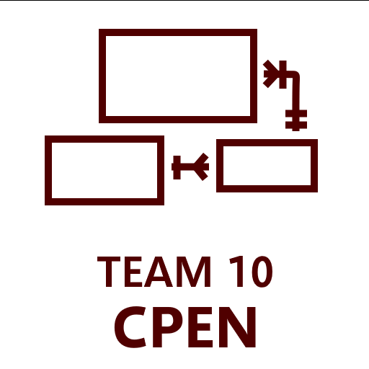

Alexander Nuccitelli

Zhongyou Wu

Utsawb Lamichhane

Zane Meikle

Sean Lee

Jonathan Moore

# Retrospective Summary

During the retrospective, we acknowledged a key issue: the tendency to leave tasks until the last minute, causing stress for the team. This was compounded by our unfamiliarity with the tech stack, leading to a steep learning curve. Although we grasped the basics for completing tasks, our understanding of the tools was incomplete, potentially posing future problems.

To address this, we've decided to front-load tasks in upcoming projects to avoid last-minute rushes and reduce stress. This shift aims to create a smoother workflow and enhance productivity. By tackling tasks earlier, we can distribute the workload more evenly and allow ample time for troubleshooting and refinement.

Despite these challenges, we successfully met our backlog goal. This success was due to accurate estimations and the dedicated contributions of each team member. While we celebrate this achievement, we understand the importance of addressing underlying issues to prevent future complications.

In future sprints, we'll prioritize gaining a deeper understanding of our tech stack. This proactive approach will involve investing time in comprehensive learning to improve our proficiency with the tools. By doing so, we can mitigate potential risks and leverage the tools more effectively as a team.

Overall, this retrospective provides a valuable opportunity for reflection and improvement. By confronting these challenges directly and implementing strategic changes, we're confident in our ability to navigate the project in the future more efficiently and cohesively.

# GitHub Release Link

<https://github.com/csce-315-331-2024a/project-3-full-stack-agile-web-902-10/releases/tag/v0.1.1>

# Product Backlog

<https://github.com/orgs/csce-315-331-2024a/projects/42/views/1>

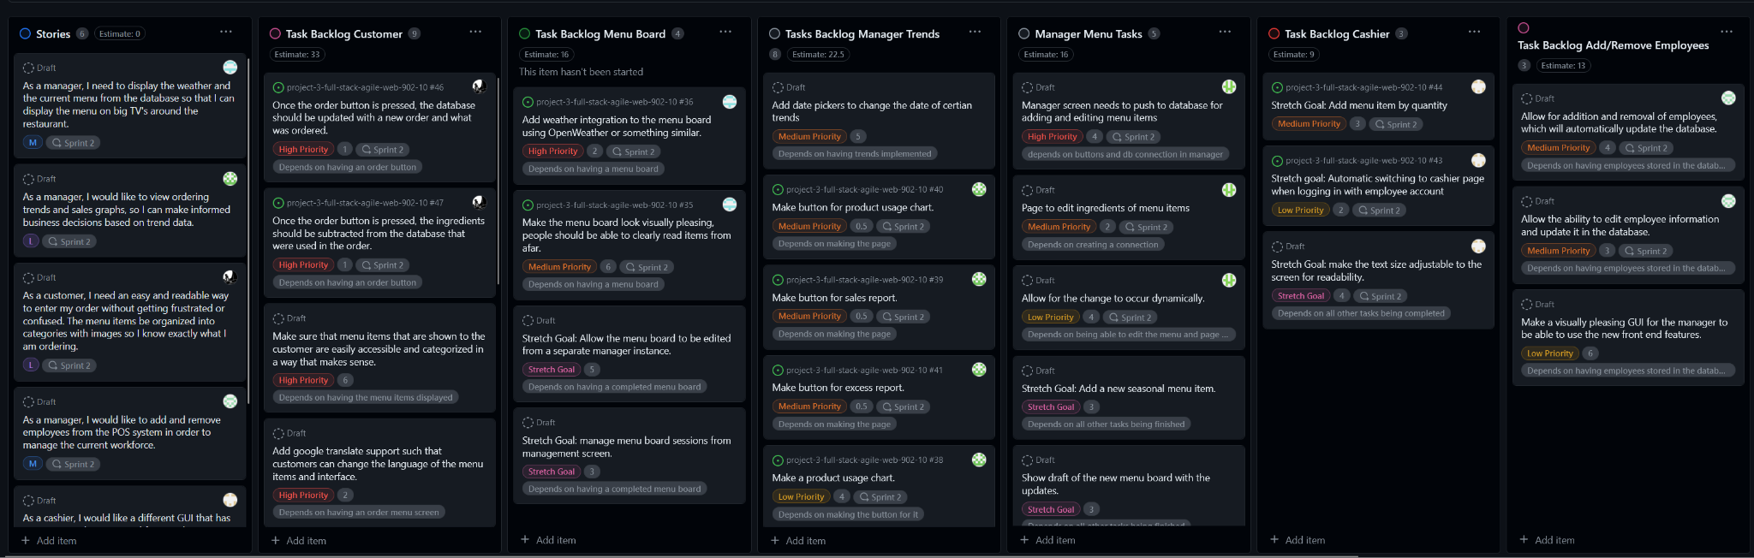

Sprint Backlog

<https://github.com/orgs/csce-315-331-2024a/projects/42/views/3?filterQuery=iteration%3A%22Sprint+1%22+>

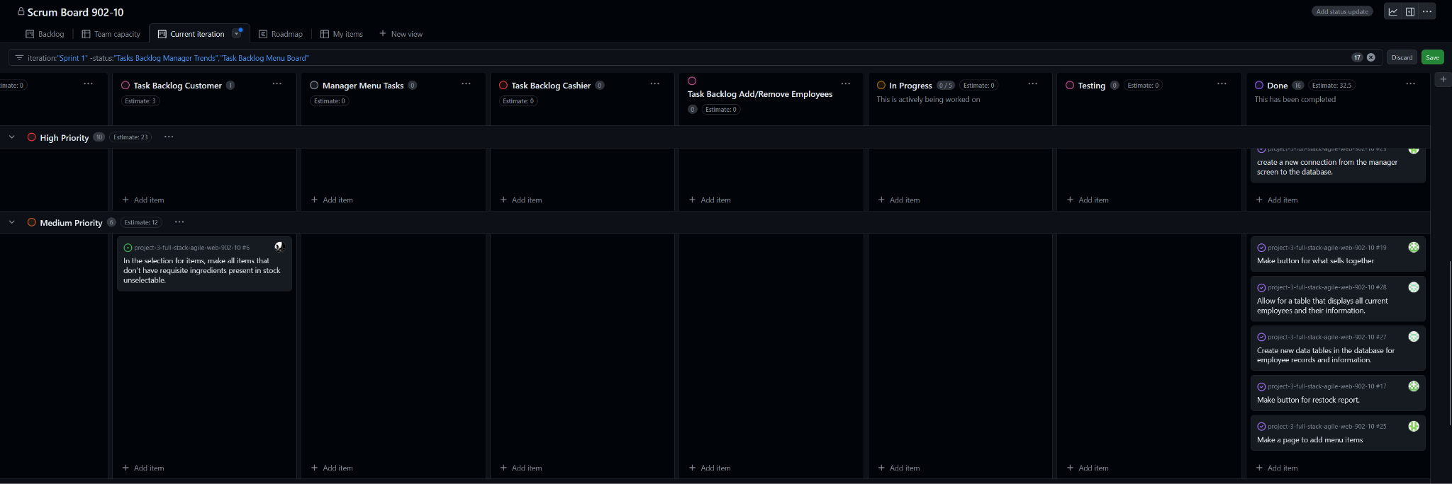

Summary for the sprint: The number next to each team member name is the number of tasks completed. It’s also the same amount assigned to them.

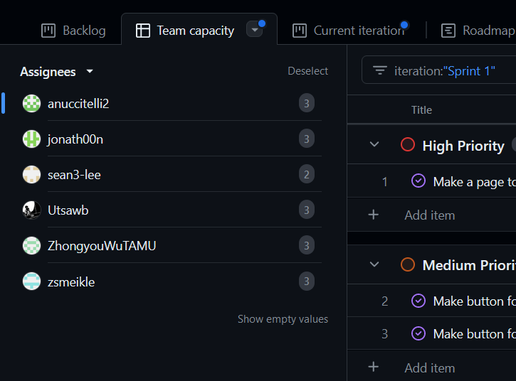

# Burn-down Charts

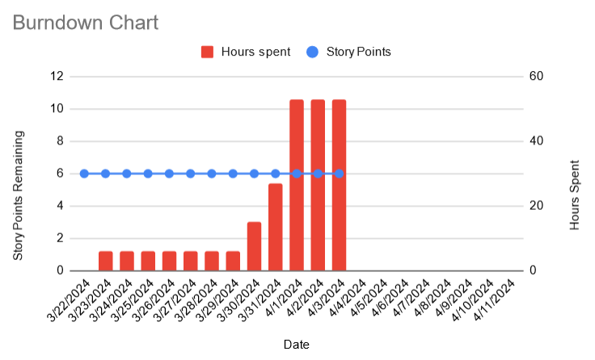

Note: Tasks are updated during each meetings, the plateau from March 23rd to 29th was a result of no work being put into the project. Our story points are also relatively large so none of them are completed yet.

# Next Sprint’s SCRUM Meeting Schedule

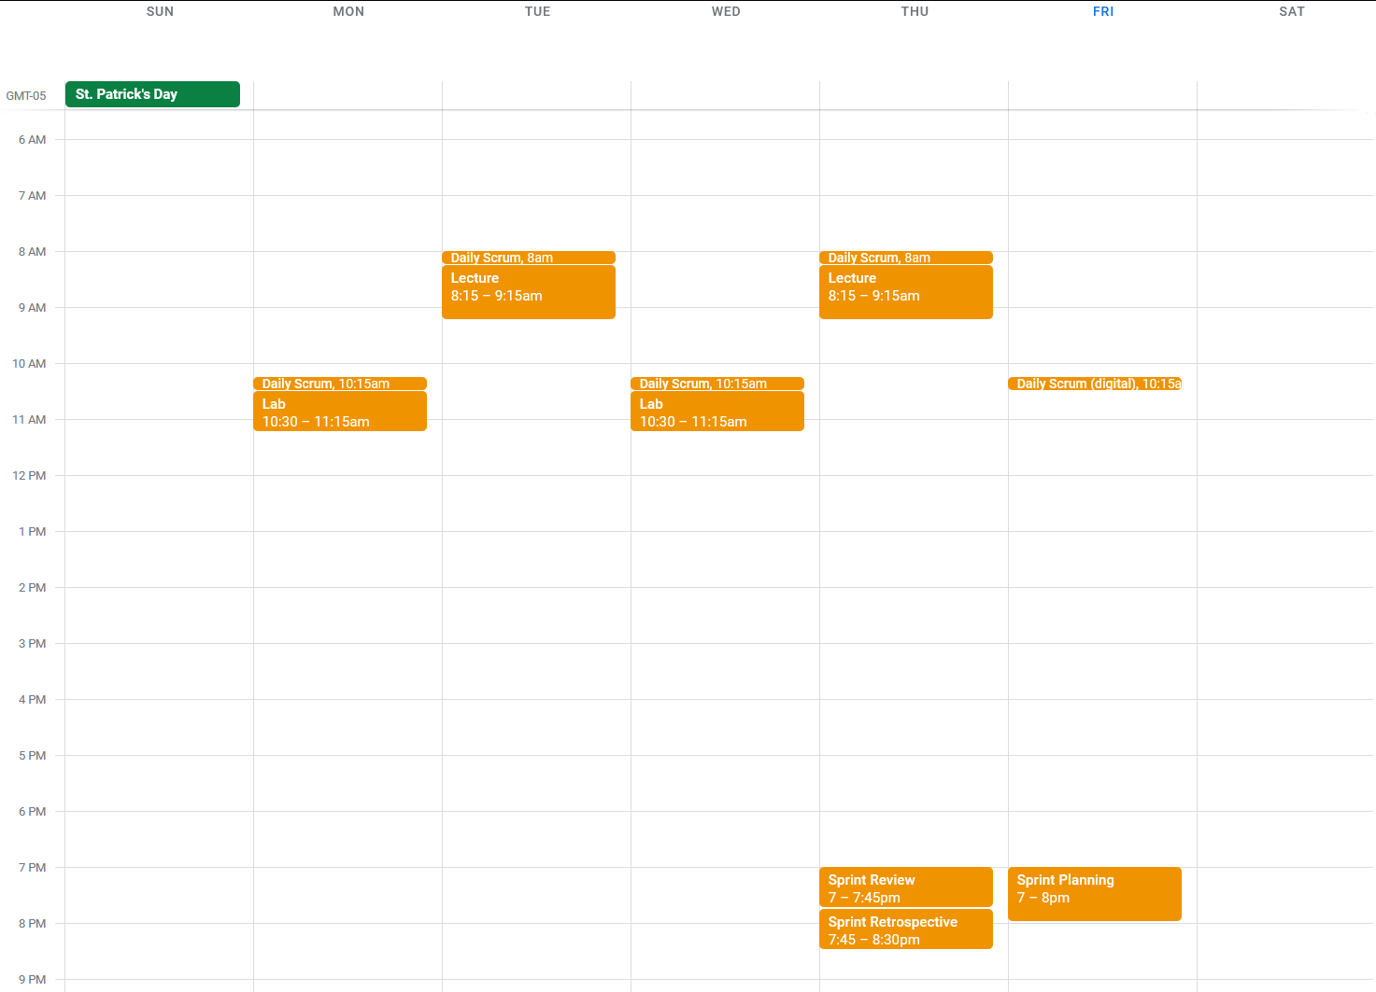

# Appendix 1: SCRUM Meeting Agendas and Minutes

SCRUM Meeting 1 for Rev’s American Grill Web App POS

Prepared by: Zhongyou Wu

Meeting Date: 3/26/2024

Meeting Attendees: Alexander Nuccitelli, Zhongyou Wu, Utsawb Lamichhane, Zane Meikle, Sean Lee, Jonathan Moore

Meeting Agenda Items: What did we do, what we are planning to do, and impediments

Status Update Since Last Meeting: Login page is implemented  
Accomplishments: Utsawb got the login page working with Google Auth.

Tasks Completed:

| **Task Description** | **Assigned to** | **Completed? (yes/no)** |
| --- | --- | --- |
| Create login page | Utsawb | Yes |
| Implement Google authentication to login page | Utsawb | Yes |

Before The Next Meeting: Plans:

* No specific plans mentioned.

Task Assignments:

* No new task assignments made.

Minutes from Previous Meeting: The previous meeting discussed the initial setup of the project, task assignments, and expectations. Assignments were made, including the creation of the login page and implementing Google authentication, which Utsawb successfully completed.

SCRUM Meeting 2 for Rev’s American Grill Web App POS P

repared by: Zhongyou Wu

Meeting Date: 3/27/2024

Meeting Attendees: Alexander Nuccitelli, Zhongyou Wu, Utsawb Lamichhane, Zane Meikle, Sean Lee, Jonathan Moore

Meeting Agenda Items:

Status Update Since Last Meeting: Accomplishments:

* No specific accomplishments mentioned.

Tasks Completed:

* No tasks were completed since the last meeting.

Before The Next Meeting: Plans:

* No specific plans mentioned.

Task Assignments:

* No new task assignments made.

Minutes from Previous Meeting: The previous meeting was mainly about task assignments and setting up goals for the upcoming sprint.

SCRUM Meeting 3 for Rev’s American Grill Web App POS Prepared by: Zhongyou Wu Meeting Date: 3/28/2024 Meeting Attendees: Alexander Nuccitelli, Zhongyou Wu, Utsawb Lamichhane, Zane Meikle, Sean Lee, Jonathan Moore

Meeting Agenda Items:

Status Update Since Last Meeting: Accomplishments:

* Alex: Developed 2 manager trends pages, pulled from the database.
* Sean: Created the cashier page and a database generator.
* Johnathan: Developed the manager screen and ensured its connectivity to the database.
* Zane: Created the backend for the menu board and made it cycle.
* Wu: Developed the employee management screen, displaying all employee users.

Tasks Completed:

* Various tasks related to feature development were completed as mentioned above.

Before The Next Meeting: Plans:

* Alex plans to complete all trends.
* Sean plans to refine the cashier page in sprint 2.
* Johnathan plans to make the manager dashboard push data to the database in the next sprint.
* Zane plans to make the menu board scroll seamlessly and create a rough sketch for the image.
* Wu plans to add the option to edit employee information.

Task Assignments:

* No new task assignments made.